Baluchari sari: Bankura

Baluchari saree is one of the most popular sarees in Bishnupur. The world-renowned Baluchari-design was inspired by terracotta tiles from the temples. Baluchari designs are inspired by mythology, tribal lifestyle and social life. It is worn by women in the states of West Bengal ,Tripura and Assam.The sari is named after the mythological scenes depicted on its anchal. It takes around one week to make one sari. In 2011, the sari was granted Geographical Indication (GII) for West Bengal, India.

Batik: Birbhum,Hooghly, Howrah, Kolkata, PurbaMedinipur

Batik is a centuries-old art technique that uses wax and dye to produce a visual effect on fabrics. The term Batik is believed to be derived from the Ambatik word, which, when translated literally, means “a cloth with tiny dots” or “writing with wax”, or “drawing in broken lines”.There are three basic steps to creating a Batik piece:WaxingDyeing,Scraping, or removing.

Brass & Bell Metal: Murshidabad,Nadia, Birbhum, Bankura,PaschimMedinipur, PurbaMedinipur, Darjeeling

Brass and brass-based works are widely used in the Kolkata area for making utensils and decorative and home utility products. It has been passed down through generations and this precious piece of art finds many buyers. You can even buy pai, which is the tool used to engraved brass work on wood bowls. It is usually sold in a pack of eight and apart from home decoration purposes, it is also used to measure the paddy and the rice. Khagra artisans, located in the outskirts of Kolkata, are well-known for producing beautiful products with a deep sheen and a fine finish. Ghatal, Purulia and Chandrapur artisans in Bankura are famous for moulding larger items in a beautiful manner. Chandrapur's artisans have an amazing knack of engraving the heads of gods and goddesses whose idols are also made with metal.

The Dhokra, also known as Dokra, is a beautiful tribal art that shows the immense skill of tribal artisans. Various kinds of Dokra ornaments and beautiful home decoration items, idols of Gods and Goddesses can be made from Dokra.The system of metal casting that is being used in the art of Dokra is the oldest system of metal casting and is technically known as 'cire perdue'.The home of Dokra art in Bankura district is Bikna village.

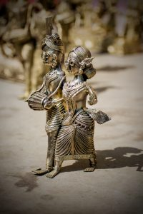 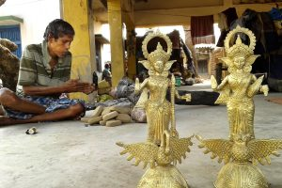 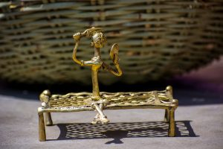 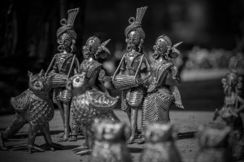

The **Lantern** industry is also very much popular in Bishnupur. You can buy these beautiful lanterns to use as collector’s items. The lanterns are used in luxurious hotels, offices, houses as home decors. It is considered to be a beautiful gift item as well. 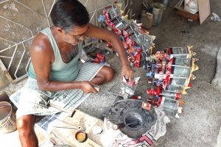

The conch shell industry in Bankura district is well-known. The people called Shankhabaniks or 'Sankharis' used to make designer Conch bangles or 'Sankha' for married Hindu women.

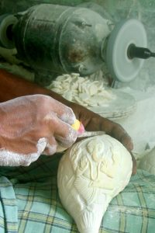

### Cane and Bamboo Handicrafts: Darjeeling,Jalpaiguri,Coochbehar, UttarDinajpur, DakshinDinajpur, Malda,Murshidabad,Purulia,Bankura,PaschimMedinipur, PurbaMedinipur, North 24-Parganas

The two most used materials in West Bengal are cane and bamboo. Products made from bamboo include household implements, construction of dwelling houses, weaving accessories, and musical instruments.

**Sitalpati:**

Sitalpati mats made from Mutra cane is one of the unique and beautiful manifestations of the grandeur of West Bengal. Sitalpati mats are also called ‘cool mats’ because they impart coolness.

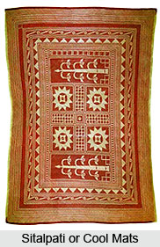

**Basketry:**

Another well-known and well-appreciated craft in West Bengal is basketry. Cane basket is made of a special type of cane found in north Bengal. These cane canes are very durable and the baskets made of them are used to carry lots of stones, bricks, and grains. Bamboo winnowing baskets are also beautiful. A special variety of bamboo basket is made for marriage with auspicious paintings. Flower basket, oblong casket and oval box are also worth mentioning in this art.

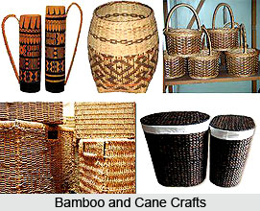

**Clay Dolls~Krishnanagar(**  
Nadia, Murshidabad,Kolkata

# )

Of all the crafts in the state, clay doll making is one of the most popular. These beautiful, vibrant clay structures are covered in bright colours. Doll making has become a part of West Bengal's culture. These dolls are real life stylized and portray different social situations in India. The real specialty of this craft is to capture and recreate daily life, work, atmosphere and characters - farmers, weaving, rag picking, basket making, umbrella makers, etc. because a lot of different figurines are made - from insects, representation of folklore, popular human figures, animated cartoons, etc. - these clay dolls fit in every setting perfectly.

